Experiment no-7
Online Beauty Parlour Appointment Booking System
AIM:
To develop an online beauty parlour appointment booking website using HTML, CSS, and JavaScript to view services and available appointment slots. The system allows customers to book, reschedule, and cancel appointments and enables administrators to manage services and reservations.
Procedure:
- Create an HTML form to enter customer details.
- Add service selection and appointment date fields.
- Apply CSS to style the form.
- Use JavaScript to validate the details.
- Display the appointment confirmation.
Sample Code:

<!DOCTYPE html>
<html>
<body>
<h2>Beauty Parlour Booking</h2>
<input id="name" placeholder="Customer Name">
<select id="service">
<option>Haircut</option>
<option>Facial</option>
<option>Makeup</option>
</select>
<input type="date" id="date">
<button onclick="book()">Book Appointment</button>
<p id="result"></p>
<script>
function book() {
let n = document.getElementById("name").value;
let s = document.getElementById("service").value;
let d = document.getElementById("date").value;
if (n && d) {
document.getElementById("result").innerHTML =
"Appointment booked for " + n + ": " + s + " on " + d;
} else {
document.getElementById("result").innerHTML =
"Enter all details";
}
}
</script>
</body>
</html>
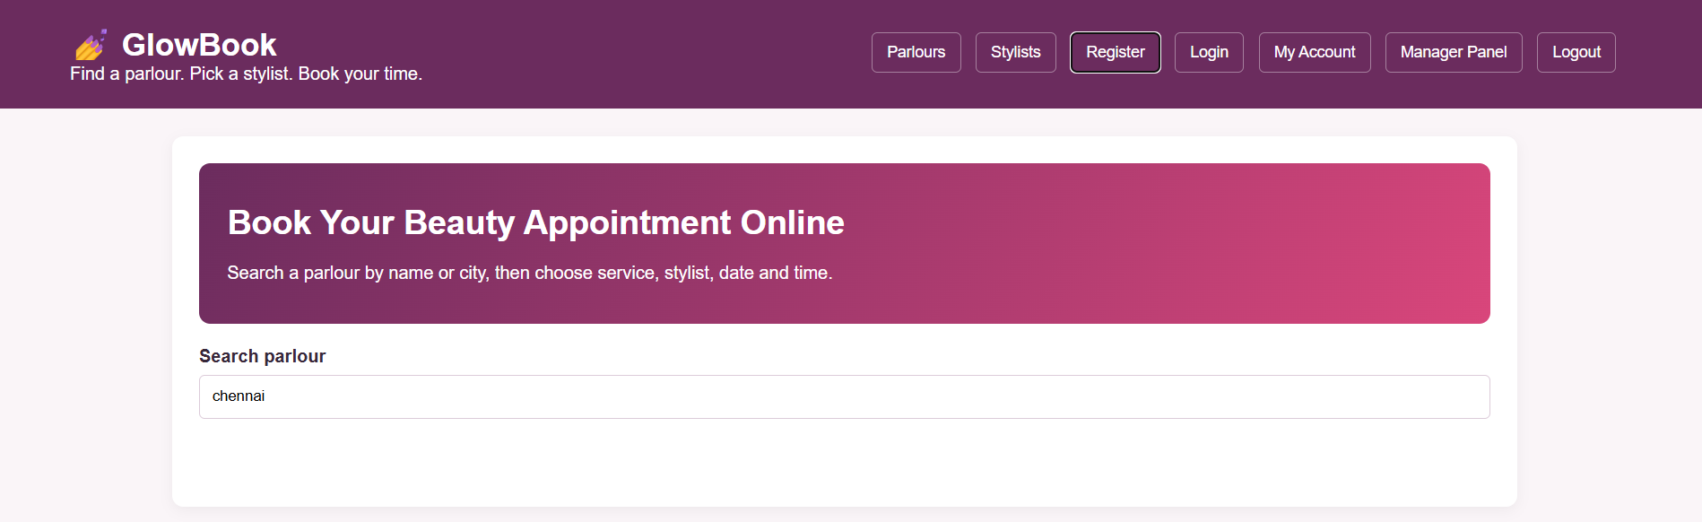
Result:
Thus, the beauty parlour booking website was developed successfully to select services, enter appointment details, and display booking confirmation.

